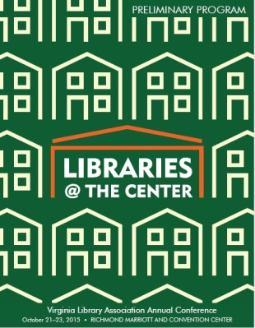 | Finding what Fits: Communication Strategies at the Center of Faculty/Liaison Interaction  By Cori Strickler, Bridgewater College & Anne Driscoll, George Mason University  October 22, 2015  Discussion Summary

Comments

Participants at this meet-up made many good suggestions on how to connect with faculty. They included:

- Make a special effort to reach out.
- Find a cheerleader – word of mouth is an excellent way to connect with new faculty.
- Connect to faculty through social media including LinkedIn, Twitter, and Facebook.
- Connect with your campus IT people to become a presence on Blackboard
- Creating a space at your library for adjunct faculty
- One person said the created an online information literacy instruction module for their faculty members. It is part of the onboarding process.
- Showcase faculty publications. Make it a regularly changing display. Let faculty know when their books are being displayed.
- Become familiar with faculty research and send them relevant articles
- Try to become involved in your departments’ hiring process. In that way you can meet them while they are interviewing.
- Attend adjunct and/or faculty orientations. Let them know you are there for them including specifically what you can do for them
- Start a faculty book club. Hold it in the library.
- See if your faculty are on Twitter or other social media then follow them.
- Make friends with department administrative assistants, they will let you know when new people are hired
- Get on department list-serv’s
- Personal interactions are the key that leads to everything else.
- Attend campus events – it is a great way to meet faculty
- Had a happy hour for faculty – it was very successful with new faculty
- Invite faculty who have recently gotten tenure and new faculty. Ask them to select a book which is critical to their area. Then put a book plate in it with their name on it.
- Need to focus on a specific area or specific area of expertise
- Move campus events into the library: scholars program presentations, faculty receptions, displays of faculty work for the year
- VCU librarians are faculty – attend faculty senate meetings, etc. – it shows interest and dedication
- Try to get onto adhoc meetings – for instance teaching with technology
- People interested in certain areas are getting together an discussing a specific topic to get to know other campus members
- Join committees which are for anyone – parking, etc.

Frustrations included:
- Can be hard to get a face-to-face or telephone conversation with faculty especially adjuncts.
- Things like the book group mentioned above went like gangbusters for a while, but then petered out.
- Only have success with people who come back over and over
- If not faculty, may not be invited because there is too much confidential information

